**Rough Intro to the Abstract:** For my honors thesis, I will inquire about the novel COVID-19 pandemic’s differing behavioral reactions on behalf of varying socio-economic, racial, age, and sex groups in the United States through demographic analysis with data collected from early Spring 2020 until now. The three main subtopics relative to each of these demographic categories will be mortality, migration, and fertility.

**Revised Abstract:** For my honors thesis, I will inquire about the novel COVID-19 pandemic’s effect upon fertility, mortality, domestic migration, and international migration from the scope of national, state, and county levels in the United States. I will use a process of demographic analysis with data collected from the U.S. Census Bureau beginning in 2010 until July 2020.

~~The study of changes in mortality rates will entail an analysis of evolving life expectancy rates, which should yield a scale of vulnerability from the opposite ends of each demographic category (i.e., the lower class likely experienced greater deaths than the members of the comparatively smaller upper class).~~

~~The study of changes in migration will pose questions such as ‘were the aforementioned groups able, permitted, and subsequently chose to travel where there was less exposure to the virus?’, ‘were multi-national businesses less able to relocate their employees and facilities?’, ‘did refugees experience more resistance to gaining green cards, asylum, and Temporary Protected Status distinctions?’, etc.~~

~~Thirdly, my research into changes in fertility, likely depicted with population pyramid diagrams, has an objective of discovering if people chose to have less children due to social distancing and stay-at-home orders, and if this development caused upheaval for current U.S. citizens in need of support from their descendants for future healthcare and social security.~~

~~Furthermore, I would like to explore the consequential economic and political dimensions of these demographic features experienced at the start of the American 2020’s. To expound upon this, I will use quantitative techniques and legislative regulations for reference to procure and interpret data regarding which subgroups of our society respect the Center for Disease Control’s recommendations or which of those have become embittered and refrain from social distancing, wearing facemasks, etc. A possible explanation which I may consider is that differing cultures are more family-gathering-oriented rather than those that are more individualized. Otherwise, it could be a matter of living sustainably, such as how poorer households must work closely together for their family unit to make ends meet.~~

~~Additionally, I will analyze the element of political persuasion, which causes tension in response to Coronavirus regulations, and is also heavily dependent upon regional settings (i.e., many rural inhabitants scoff at regulations while many urban inhabitants realize that it is a necessity).~~

~~Lastly, something anecdotal to consider, someone who abides by social distancing regulations but is likely living affluently may cynically say to someone of low-income, “so you lost your job, foreclosed on your home, became a victim of domestic violence, got depression, and watched your kids fall behind in school? Though this may be the case, you would not want to contract a disease with a 99.99% survival rate, would you?” Relevant to this scenario, Dr. Anthony Fauci stated that, “1% mortality rate means it is ten-times more lethal than the seasonal flu [which is something that] people can get their arms around and understand.” My research will attempt to draw a conclusion to the differing perspectives behind this anomaly.~~

______________________________________________________________________________

5/17/2021

*To assess what exactly COVID-19 entails for the demographic future of the country, I used midpoint year data which the U.S. Census Bureau collected. Although the use of this data causes the loss of granularity, it allows for more rapid, contemporary data to pinpoint when an event occurs. Also, since the COVID-19 pandemic gained traction in the United States in March 2020 (i.e., before the midpoint of July), its effect will be statistically reflected in mortality and migration rates. However, fertility rates will not present any noticeable change due to the Coronavirus since births did not decline until the end of the year.*

* Recent change in birth rates: Births decreasing at a slower rate for the most recent stretch.
* Recent change in death rates: Drastic increase due to COVID-19 breakout.
* Recent change in domestic migration (explanation as to why my graph used to be 0 minus 1? Due to one county gaining a citizen while the old county loses the citizen): Slight increase in rate likely due to people moving back to their family’s residence to quarantine.
* Recent change in international migration: International migrations decreasing at a slower rate (likely due to international travel bans which the Trump administration implemented being annulled as well as citizens taking advantage of the vast decrease in airfare prices before other countries began barring entry to Americans who were scrutinized because of the rise in cases

…

**Introduction**

[General Introduction to topic]

[Gap in the literature 1] – Highlight the Lack of Current Research Regarding the Coronavirus’s effect upon migration.

[Gap in the literature 2]

[What I plan to do in this paper]

[Short paragraph of initial findings. This is the teaser]

**Data and Methods**

[Describe data and methods] – R Studio using the Census Bureau’s csv files.

**Results**

Results General

Figure 1. Overall US trends by fertility/mortality/migration

[Describing the figure: fertility. Maybe talk about why fertility might have fallen.]

[Describing the figure: mortality. Maybe talk about why mortality is rising.] (Greater deaths partially and simply due to a greater national population)

[Describing the figure: domestic migration. Talk about why domestic migration is rising.] (Great Migration Slowdown)

[Describing the figure: international migration. Talk about why international migration is falling.] (Almost entirely dependent upon presidential administrations’ policies)

Results by States

Table of States Results. (One Big Table) Focus on Change from 2019-2020

[Describe the table. Probably in several paragraphs.]

Interesting Results?

Figure 2. Map by County (Four Maps) Focus on Change from 2019-2020

[Describe the Interesting Results]

**Discussion**

[Recap]

[What are the implications of your findings? Several paragraphs]

[What are the limitations?]

[What might future work do?]

5/24/2021

**Introduction**

For my honors thesis, I will inquire about the novel COVID-19 (‘coronavirus disease 2019’) pandemic’s effect upon fertility, mortality, domestic migration, and international migration from the scope of national, state, and county levels in the United States. I will use a process of demographic analysis with data collected from the U.S. Census Bureau beginning in 2010 until July 1, 2020. Although this data is secondary in nature, the Census Bureau credits the National Center for Health Statistics (NCHS) and the Federal-State Cooperative for Population Estimates (FSCPE) regarding their findings for vital statistics including fertility and mortality. However, my analysis does not account for the NCHS’s data for the past year since its completion is lagged for the next two years. Furthermore, statistics that are verified by the Census concerning the pandemic’s influence upon varying racial, socio-economic, and sex-based groups meant for indications are not presently available.

Also, I must preface my overview with a reminder of how correlation of data does not imply causation. For example, the recent decline in international migration from the U.S. cannot entirely be dependent upon quarantining lockdowns. Instead, it is prudent to surmise that many factors such as the said lockdowns, economic insecurity, and the restrictive foreign policies of the presidential administration are collectively responsible. The pandemic’s influence upon international and domestic migration in the United States particularly epitomizes a current gap in academic literature that this study will attempt to investigate.

To assess what exactly COVID-19 entails for the demographic future of the country, I have elected to use simple statistical methods to assess midpoint year data which the U.S. Census Bureau collected. The Census Bureau’s estimates serve as “mid-year” populations, reflecting the demographic components of change at the exact middle of the year which is theoretically the mean of January 1 and December 31 of a given year. For clarification, the 2011 datapoints reflect Census 2010 until the midpoint of 2011and every other successive year reflects a ‘midpoint until the next midpoint’. Although the use of this data causes the loss of granularity, it allows for more rapid, contemporary data to pinpoint when an event occurs. Also, since the COVID-19 pandemic gained traction in the United States in March 2020 (i.e., before the midpoint of July), its effect will be statistically reflected in mortality and migration rates. However, fertility rates will not present any noticeable change that is due to the Coronavirus since births did not decline until the end of the year. This facet of the data entails a gap in academic literature which I will account for in the results section of my study and offer explanations supported by available literature.

My study’s initial findings did not conclude entirely negative effects on behalf of the pandemic. Regarding fertility, births have been declining nationally since an inflection point in 2015, however, they decreased at a noticeably slower rate compared to years past in the most recent year of data collection. Unfortunately, data mirrored what would be expected from a deadly virus in the mortality spike from 2019 until last year. Surprisingly, the rate of domestic migration encountered an inflection point in 2018 and has been positively sloped since, possibly due to individuals moving to their family’s residence in a different county or state for quarantining (more to follow regarding the two sub-national spatial levels of measurement).

Lastly, the rate of international migration in the country has decreased sharply since the Trump administration finalized its restrictive foreign policies. However, it has been decreasing at a slower rate recently, which is likely due to the Biden administration and federal courts annulling the Trump administration’s international travel bans. Additionally, the phenomena of citizens taking advantage of the vast decrease in airfare prices at the onset of the pandemic before other countries began to scrutinize and bar entry to Americans is a considerable factor.

5/30/2021 … 6/6/2021

* One big table for state-level for 2019 – 2020? & ‘Map by County’?
* Had a difficult time finding recent academic literature for vital statistics. (i.e., most articles were medicine-related or inaccessible for birth rate-related scholarly sources) new source for death rates involving black race and temperature?
* Discuss Census methodologies page, ‘Hispanic origin’? … Latin and central American / Brazil and French Guinea not … only ethnicity in the U.S. that is collected … includes white Hispanic, black Hispanic, etc.
* In need of input commands for county level … NEXT FINAL STEPS FOR DRAFT: Describe vital statistics, describe two new tables, discussion!

**Data and Methods**

The entirety of my preliminary analysis involving statistics occurred within R Studio, an integrated development environment (IDE) for R, a programming language for statistical computing and graphics. Manipulating the Census’s statistical data involves coding series within R Studio to depict graphical evidence of trends in fertility, mortality, domestic migration, and international migration within the U.S. from 2010 until 2020.

This process entailed inputting ‘csv’ files containing yearly updates of population estimates added on to the last decennial census obtained from the Census Bureau’s Population Estimates Program. Each annual release from the organization accounts for a span from April 1, 2010, until July 1 of the current year. The overarching purpose of the published data is meant for federal funding allocations, business planning, community development, and to serve as a control group for major surveys.

The Bureau’s statistical collection process begins with estimating the monthly population at the national level by age, sex, race, and Hispanic origin. Secondly, counties’ total annual populations are estimated and then summed to the state level. However, their various processes of surveying and using data, including some that indirectly attains population data such as IRS tax return data and the database of Medicare recipients, all use differing input data and methodology. Thus, the Census must adjust their final population estimates to be consistent, both geographically and demographically. Suffice to say, the Bureau admits that ‘the demographic components of change do not account for all of the year-to-year change in the estimates series.’

Lastly, each successive year of data entry past 2010 incorporates legal boundary updates as of January 1. The concept of redistricting occasionally distorts, relative to the territories of the prior years, the county, city, or town boundaries. Likewise, each year past 2010 contains a new time series using the appropriate geographic boundaries for each period of estimates.

**Results**

Figure 1.

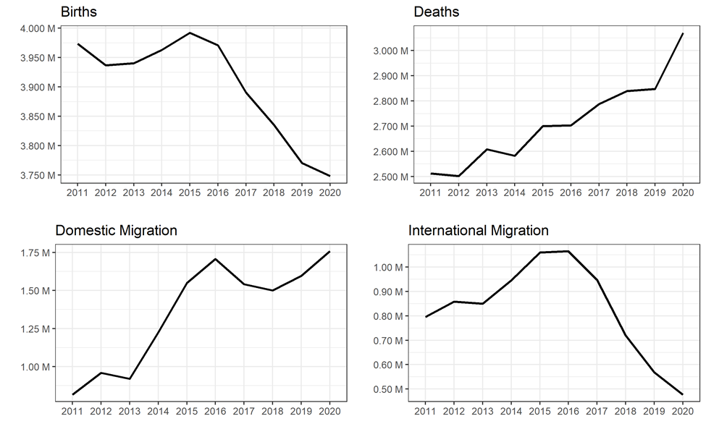

Figure 2.

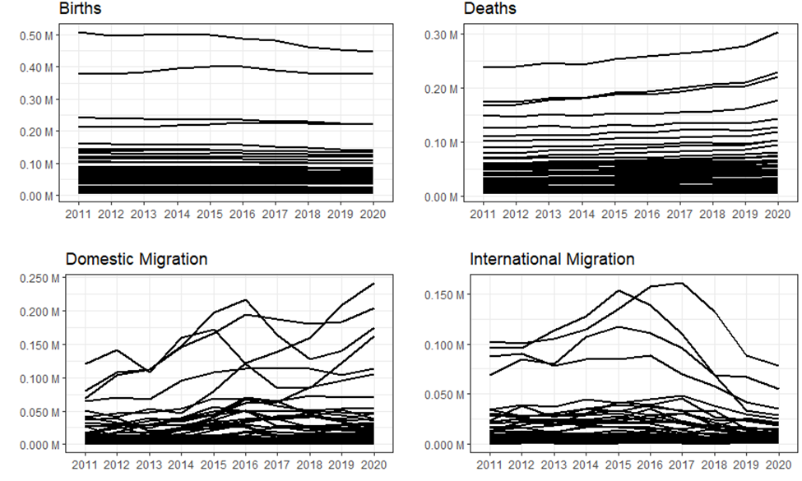

Figure 1. Overall US trends by fertility/mortality/migration

[Describing the figure: fertility. Maybe talk about why fertility might have fallen.]

[Describing the figure: mortality. Maybe talk about why mortality is rising.] (Greater deaths partially and simply due to a greater national population)

[Describing the figure: domestic migration. Talk about why domestic migration is rising.] (Great Migration Slowdown)

[Describing the figure: international migration. Talk about why international migration is falling.] (Almost entirely dependent upon presidential administrations’ policies)

Regarding the ‘Births’ graph, it is notable for depicting a consistently decreasing fertility rate, except for an inexplicable increase in the rate from 2012 until 2015. In 2017, demographer Kenneth Johnson attributed the National Center for Health Statistics’ report of a record low birth rate in the United States to the aftermath of the Great Recession which “sent an economic shock through American society that reached far beyond the stock and housing market” (p. 1). Furthermore, he explains how although there was a larger population of women in their fertile prime four years ago, more than four-million fewer babies were born in the country from 2008 until 2016 than what would have occurred had pre-recession fertility rates not been interrupted. Although we observe from the graph that the slope becomes slightly less negative beginning in 2019, the Coronavirus will rot similar long-term effects as the Great Recession did, including a thinning of the future population pyramid. This is because census data depicting the dearth of births at the tail end of 2020 is in the final stages of collection but unfortunately is not yet available. The ‘dearth of births’ which will cause the slope of the ‘Births’ graph to negatively veer in the next year is the consequence of social distancing regulations that were implemented in March 2020 creating an obstacle for sexual reproductivity.

As it is immediately evident from observing the ‘Deaths’ graph, mortality rates in the United States have consistently increased, aside from years of stagnancy including 2013, 2015, and 2018. As previously stated, statistics that have been collected by the Census regarding racial, socio-economic, and sex-based groups are not presently available. However, research conducted by neurosurgeon Adam Li and his associated scholars possesses resounding conclusions surrounding racial and location-based factors that posit individuals to be more susceptible to death from COVID-19. Regarding sectors of industry that put subgroups of society in harm’s way, fewer than one in five African Americans have a job that gives them the flexibility to work from home, which is mainly due to Black Americans making up a large share of the “essential” industries of healthcare, transportation, government, and food supply (Li et al., 2020, p. 8). Furthermore, the nearly one million transit workers that remained after an eighty-seven percent reduction in ridership were predominantly low-income people of color. Another health-related factor that made Black Americans more vulnerable to the pandemic was the finding that seventy-one-point-nine percent of non-Hispanic Black individuals were found to suffer from vitamin D deficiency. Vitamin D has been found to be essential for survival amid the pandemic due to its “important modulatory effect on immune response” (p. 9). The increased melanin pigmentation that is characteristic of people of color absorbs greater amounts of radiation than that of the skin of non-people of color which reduces ultraviolet-B radiation which is needed to trigger the production of vitamin D. The researchers also concluded that the protective effect of warmer climates which allows vitamin D to be cultivated at a greater rate causes a reduction in COVID-19 cases, but not mortality. Otherwise, one should expect a seasonal trend in global cases, with special attention given to regions of warmer climate, and mortality (p. 9).

The researchers headed by Li also found a correlation between two factors that may initially seem counter-intuitive regarding the reported COVID-19 cases and an increase in mortality rates. As those that are poverty-stricken experienced an expedited case spread, those with economic stability found accessibility to getting tested more convenient. Also, flu vaccination was considered an indication of readily accessible healthcare. All three of these categorial qualities led to a statistically reported increase in exposure to the virus. Additionally, proactive social distancing caused decreased pollution levels, and thus pollution-related COVID-19 cases (p. 10). Lastly, the researchers conclude that the effect of either proactive or reactive social distancing is ambiguous since the former causes more cases and deaths while the latter causes widespread fear which leads to reactive social distancing. Thus, the researchers advise future studies to account for which time-based version of social distancing that is being measured (p. 11). Since my data that is the census procured from entails a point of conclusion in July 2020, I believe the first figure reflects proactive social distancing in the last yearly segment of each graph.

As evident from the national-level graph, domestic migration has steadily increased (despite a negative lapse between 2012 to 2013 and 2016 until 2018) since 2011. This graph effectively depicts the annual net migration rate, which is the difference between the inflow rate (the number of people who move into a certain state within one year, normalized by the state population) and the outflow migration rates (the number of people who move out of a certain state within one year, normalized by the state population).

According to DeWaard et al. (2017), the interconnectedness of migration between U.S. counties has noticeably offset the phenomenon known as the Great American Migration Slowdown. This refers to the negative effects of the Great Recession that entailed an unprecedented surge in housing values and homeowners’ debt. The researchers go on to state that the ‘Slowdown’ is rooted in gradually widening socioeconomic inequality which leads to a decline in migration intensity and an increase in migration connectivity (p. 21). Furthermore, Lin et al.’s (2019) research that involved migrant-based internet search queries obtained from 2014 until 2016 using big data reinforced findings of widening inequality. Their data revealed that American migrants in the lowest income bracket are the least interested subgroup regarding the science and technology sector mainly located in higher-education states. Meanwhile, American migrants in the upper echelon of income brackets are the least interest subgroup regarding the manufacturing and transportation sectors mainly located in lower-education states. Additionally, the research team behind these inferences demonstrated how records of internet search queries involving potential migrancy are better demographic indicators than what government data offers. This technological advancement will likely lead to local governments and business leaders to be better equipped in accommodating future city and state-level planning as well as knowing whether new developments for housing should be for rent or purchase (p. 1070).

Regarding the decline of international migration within the United States since 2016, the emphasis placed upon strict customs enforcement has remained stagnant for fifty years prior to the election year. In 2018, the number of foreign-born residents had doubled since 1990 to comprise about thirteen percent of the population. Also, despite the negative impact of the great recession, the arrival of new undocumented migrants roughly offset deportations that have averaged three-hundred thousand annually. Essentially, the preservation of the status quo provided ammunition for populist politicians that the Trump administration emboldened (Waldinger, 2018, p. 1421 – 1422). The administration’s political intent also seemed to empower a decline in legal, and therefore statistically reported, migrants.

More directly pertaining to the Coronavirus, Lau et al. (2020) found a “direct correlation between passenger numbers between mainland China and international destinations and diagnosed COVID-19 cases outside of China” (p. 470). Additionally, evidence pointed to the international spread of COVID-19 to be solely attributable to air traffic and passenger numbers rather than mobile transportation. Also, newly diagnosed Coronavirus cases with potential travel history to China caused nations such as Italy and Iran to become secondary epicenters in early 2020. This development aided in the spread of the virus but also caused statistical analysis to be cumbersome since international flight restrictions were implemented in China in late January 2020 while the previously stated nations had not yet implemented restrictions (p. 471). The issue in this case was that it became impossible to cross-reference an internationally closed-off origin of the virus, China, with newly infected global regions that still served as continuous international flight routes. Also, many countries reduced human contact “through limiting large gatherings, closing schools, or implementing total lockdowns” (Linka et al., 2020, p. 1089). Suffice to say, the restrictions placed upon international air traffic and communal gathering directly aided a declining rate of international migration.

This increased disease burden did not seem to be explained by previously proposed mechanisms, indicating that other modulating factors should be considered, and novel interventions designed appropriately. One potential domain includes additional sociocultural variables that have only now become relevant within the context of the pandemic. For example, African Americans make up a large percentage of the healthcare, transportation, government, and food supply industries, job sectors that have now been deemed “essential” services in light of the SARS-CoV-2 pandemic. Despite the majority of Americans currently living in counties with some form of social distancing mandate, fewer than one in five Black Americans have a job that gives them this flexibility to work from home, compared with more than a third of white and Asian American workers. The potentially fatal consequences of this fact can already be seen in the case of the New York City transit workforce, which has been among the hardest hit by the virus with more than 2,000 cases and 59 deaths.57 Despite making up just 24% of the city’s overall population, African Americans account for nearly half of transit workers.36,37 Furthermore, despite an 87% reduction in overall ridership since the pandemic began, the nearly one million remaining passengers–most of whom lack the luxury of social distancing due to essential employment–are predominantly low-income people of color.

A potential explanation may be that Black workers may be more likely than other minority groups to work essential jobs that also require close proximity and frequent contact with others, such as bus drivers, postal workers, and grocery store clerks, which would convey additional risk of COVID-19 infection.

In this comprehensive analysis of serum 25-hydroxyvitamin D (25(OH)D) levels collected from more than 26,000 adults in the United States between 2001-2010 as part of the National Health and Nutrition Examination Survey (NHANES), 71.9% of non-Hispanic Black individuals were found to suffer from vitamin D deficiency (defined as

(PAGE 8)

serum concentrations of less than 50 nmol/L) even after controlling for other potential predictors.41 Of the many sociodemographic, behavioral, and clinical variables studied, being a racial or ethnic minority was the strongest predictor of vitamin D deficiency.

Vitamin D has been suggested as a potentially mitigative factor in the COVID-19 pandemic due to its important modulatory effect on immune response.42,43 Furthermore, vitamin D deficiency has been implicated in numerous adverse health conditions such as acute respiratory syndromes, tuberculosis, cardiovascular disease, autoimmune disease, and some cancers. This higher prevalence of vitamin D deficiency in darker-skinned individuals is thought to largely be due to increased melanin pigmentation, which absorbs significantly more radiation from sunlight and thereby reduces the available ultraviolet-B radiation that is needed to trigger natural vitamin D production in the skin.

The potential role of vitamin D as a modulator of COVID-19 burden is further supported by our other significant finding regarding temperature, which suggests a protective effect of warmer climates. Several recent reports have also linked higher temperature to decreased virus spread, while others have found no significant effects.9-14 Here, we demonstrate an independent effect of temperature that results in reduced COVID-19 cases, but not mortality, across U.S. counties. If warmer temperatures do, in fact, play a role in mitigating disease spread, it is reasonable to expect a potential seasonal trend in global cases and mortality.

(PAGE 9)

Poverty and GDP are not typically thought to be positively correlated with each other, however, the correlations seen here may represent inequalities in health care versus and access to testing. For example, poverty may exacerbate case spread, while economic power increases testing rates, both of which would lead to increased cases. Flu vaccination was included as a marker for access to healthcare and may be associated with greater testing rates. Additionally, flu vaccination is often mandated for healthcare workers, thus counties with higher flu vaccination rates may have more of its citizens having front line exposure to the virus.

Given increased social distancing, many counties with historically bad air pollution currently have significantly decreased pollution levels, which may have decreased pollution related COVID-19 cases.

(PAGE 10)

It is expected that less proactive social distancing will cause more cases and deaths (negative correlation) while higher numbers of cases and deaths induces fear, causing increased reactive social distancing (positive correlation). Since these effects work in opposite directions, this bias makes it more difficult to find an effect of social distancing. Studies that plan to model social distancing with numerous covariates should ensure their metric adequately delineates between proactive and reactive social distancing or employ an appropriate instrument to remove this simultaneity.

(PAGE 11)

_____________________________________________________________________________________________________________________

High-High represents clusters of recorded births within counties that are significantly, in a statistical sense, higher (greater than the mean) and situated together using ‘queen contiguity’, in comparison to lesser neighboring counties.

Low-Low represents clusters of recorded births within counties that are significantly, in a statistical sense, lower (lesser than the mean) and situated together using ‘queen contiguity’, in comparison to greater neighboring counties.

High-Low represents a county that can be considered a spatial outlier since it possessed a remarkably greater number of births relative to neighboring counties, by a notably larger margin than High-High.

Low-High represents a county that can be considered a spatial outlier since it possessed a remarkably smaller number of births relative to neighboring counties, by a notably lesser margin than Low-Low.

Albany, GA: High mortality … mortality clusters

I must repeat the disclaimer that this depiction of fertility does not present the effect of the decline in births experienced towards the end of 2020, which the Coronavirus caused. Drastic decreases or increases in fertility were rarely observed if at all. The coastal regions are by-and-large represented with the lighter shade of ‘pink’, indicating little change in fertility, whereas the lighter-green distribution that entails fertility growth appears to be concentrated by-and-large in the Midwest and states that comprise the Rocky Mountains (which may be due to larger counties by land mass).

Zones of spotty improvements in mortality seem clustered within the inland western and mid-western regions. Although the effect of increased mortality can be observed in the states that comprise the Rocky Mountains and the Midwest, lower mortality rates seem practically exclusive to the direct center longitudinal line of the country (i.e., Texas, New Mexico, Nebraska, South Dakota, and North Dakota). To be more precise, the populated coastal borders saw a moderate increase in deaths from the years 2019 to 2020.

*NOT ENOUGH CONCLUSIVE DATA TO STATE THAT PEOPLE WERE FLEEING CITIES FOR AREAS OF AMENITIES* SPATIAL AUTO CORRELATION – CLUSTERING – MORAN’S I

The trends of concentrated gain or loss of domestic migrants seems unable to be inferred due to the practically random appearance-based distribution. Although a vast decrease in domestic migration seems ubiquitous for the country, there seems to be an equal apportionment of great increase contrasted with great decrease of domestic migrants per each state. Essentially, the spatial occurrences of pronounced domestic migration were found within mid-sized cities. However, the theory that urbanites were leaving large metropolises in a mass exodus for less populated rural lands due to inconvenient regulations intended to slow the spread of the Coronavirus has been found to be inaccurate.

Most U.S. counties experienced a slight increase or a stagnant rate of international migrancy from 2019 to 2020. In fact, counties that experienced a substantial decrease in international migration were increasingly decentralized and few-and-far-between. States within the northeastern and southwestern regions experienced minimal change while almost all other regions experienced a notable increase. However, this map possesses the most ‘N/A’ counties since some counties’ reports of international migration were incomplete or inaccurate.

Green means more international migrants moving into America?

**‘Speculation’ Similarities and Differences (lacking in IRS data)**

From 2019 until the following year, the coastal regions of the United States have been depicted showing a slightly negative change in fertility, a slight but notable increase in mortality, a polarized, but unable to be summarized trend in domestic migration, and a theme of less international migration. In contrast, the inland regions experienced an improved state of fertility, while also incurring the greatest detriments and benefits regarding mortality. However, both international and domestic migration notably declined in the landlocked states, except for midwestern ‘pores’ of increased international migrancy.

…

“Florida could lose more than 2.5 million residents due to 1.8 m of SLR, while Texas could see nearly 1.5 million additional residents (Fig. 2). Additionally, nine states could see net losses in their populations due to SLR.” – Disagrees with map? … comparing apples and oranges … the popular reception posits that the effect of the pandemic has led migrations toward suburban areas – areas less bound by COVID restrictions … we do not see this in the data

*Age? Employment? COVID Rates?*

“In short, MSAs with relatively large numbers of older residents are clearly heterogeneous with respect to location, to the demographic and economic forces that brought about this type of age structure, and ultimately to their recorded rate of population growth during the most recent intercensal period.” (Serow & O’Cain, p. 224)

*Counties’ population change are heterogenous relative to the COVID changes that shape their population dynamics*

**Future Implementation (Separate Modules)**

~~Data and Methods: Discuss statistical transformations we did with data~~ …

Results: state-level data (should comprise three pages at least) … will influence limits of study and conclusion

Discussion/Conclusion: Drivers of relationships: Work from home? Cost of living? Access to medical care? Housing stock (maybe)? ~~Transmit PowerPoint slides’ points to word doc~~

Carl’s Suggestions: Rate (index of counts) vs. Count, ~~why are births really declining?~~

Hauer’s Method: Intro, Results, Data/Methods, Discussion/Conclusion

8/24: Add to Data & Methods: The primary set of commands that were input into R Studio were used to organize the evolving demographic records collected by the Census which included states and counties’ numerical listings of births, deaths, and migrants. Other commands were necessary to depict the continental United States, including states’ borders and the noncontiguous states of Hawaii and Alaska. Additionally, diverging color schemes attributed to ColorBrewer were used to identify certain counties and states’ percentage-based categorization relative to births, deaths, domestic migration, and international migration. Most importantly, the equation attached to the variable ‘perdrop’ (percentage drop) entailed subtracting a given demographic category’s lagged quantity (meaning the numerical value of the year prior to the year possessing the quantity under consideration) from the “present” quantity under consideration, divided by the absolute value of the lagged quantity. These values were then ordered from least to greatest and underwent a process of appropriate cutoff values being applied. These ordered percentages became the basis for depicting geographical areas’ numeric and demographic change via the diverging color schemes as well as cluster maps demonstrating spatial autocorrelation.

The variable *V* is the indicator we are interested in (Births, Deaths, etc.), and *t* is a given time period. Thus, the percentage drop in any given indicator is equal to the indicator in any given year minus the value in the year prior divided by the value in the year prior. In the event a percentage that is impossible to calculate is encountered, we replaced these occurrences (i.e., 1/0, 0/0, 0/1, etc.) were replaced with 0, suggesting no change.

Regarding spatial autocorrelation, the similarity of two observations () multiplied by spatial weights ) is the generic form of Local Indicators of Spatial Autocorrelation (LISA).

______________________________________________________________________________

**Sources**

DeWaard, J., Fussell, E., Curtis, K. J., & Ha, J. T. (2017). Spatial Manifestations of the “Great American Migration Slowdown”: A Decomposition of Inter-County Migration Rates, 1990-2012. Working Paper# 2017-4, Minnesota Population Center, University of Minnesota.

Johnson, K. M. (2017). New Data Show US Birth Rate Hits Record Low.

Lau, H., Khosrawipour, V., Kocbach, P., Mikolajczyk, A., Ichii, H., Zacharski, M., ... & Khosrawipour, T. (2020). The association between international and domestic air traffic and the coronavirus (COVID-19) outbreak. Journal of Microbiology, Immunology and Infection, 53(3), 467-472.

Li, A. Y., Hannah, T. C., Durbin, J., Dreher, N., McAuley, F. M., Marayati, N. F., ... & Choudhri, T. F. (2020). Multivariate analysis of factors affecting COVID-19 case and death rate in US Counties: the significant effects of Black race and temperature. medRxiv.

Lin, A. Y., Cranshaw, J., & Counts, S. (2019, May). Forecasting us domestic migration using internet search queries. In The World Wide Web Conference (pp. 1061-1072).

Linka, K., Rahman, P., Goriely, A., & Kuhl, E. (2020). Is it safe to lift COVID-19 travel bans? The Newfoundland story. Computational Mechanics, 66(5), 1081-1092.

Waldinger, R. (2018). Immigration and the election of Donald Trump: Why the sociology of migration left us unprepared… and why we should not have been surprised. Ethnic and Racial Studies, 41(8), 1411-1426.